The Feasibility of Opening a Chinese Restaurant in Toronto and the Optimal Choice of Location

Xianan Zhang

**Introduction to the Business Problem and Background of My Project**

The purpose of this project is to analyse the feasibility of opening a Chinese restaurant in Toronto and the optimal choice for its location. Toronto, which is one of the most beautiful and multicultural cities in Canada, attracts a lot of immigrants from different countries around the world every year and among all immigrants, Chinese make up a great proportion of the entire immigrant population. In addition, Chinese cuisine has become one of the most popular food categories in the world today. People from different countries, not just Chinese, become increasingly enthusiastic about Chinese dishes. Hence, opening a Chinese restaurant in such a great city would be a good choice for those who are thinking about opening a restaurant in Toronto.

However, opening a Chinese restaurant in Toronto could also be risky. First, due to the relatively large proportion of Chinese people in the entire immigrant population, as a owner of a new Chinese restaurant, you may have to face great pressure from other peer competitors especially if you choose to locate your restaurant in areas such as downtown or Chinatown. Second, if you choose to open your restaurant in a district where it does not have many local Chinese residents, the poor customer base may result in bad outcomes for your business. Hence, the selection of the restaurant location is extremely important for a start-up restaurant.

The purpose of this project is to find out the best places to open a Chinese restaurant by analyzing the demographics and neighborhoods of each borough of the Toronto city. Specifically, this project will offer those who are thinking about opening a Chinese restaurant at Toronto but haven’t decided where to locate their restaurants some recommendations based on the analysis results.

**Data**

**The data covered in this project consist of four parts:**

1. **The List of Post codes of Canada from the Wikipedia page** <https://en.wikipedia.org/wiki/List_of_postal_codes_of_Canada:_M>**. This dataset contains postal codes, names and the neighborhoods of each borough of the Toronto city;**
2. **The geographical dataset downloaded from the link** <http://cocl.us/Geospatial_data> **which contains useful geographical coordinates of each postal code;**
3. **The dataset of the demographics of Toronto from the Wikipedia page** <https://en.m.wikipedia.org/wiki/Demographics_of_Toronto#Ethnic_diversity> **provides useful information of the population composition of each borough and neighborhood within the Toronto city;**
4. **The Foursquare’s API is used to explore nearby venues of any specific location within the Toronto city. The endpoints that I am going to use from the Foursquare’s API include the name, category, latitude as well as longitude of each venue explored.**

**Data Cleaning and Preprocessing**

**I need to clean up and pre-process my data before performing the analysis. First, I downloaded the tables of ‘The List of Post codes of Canada’ and ‘Geospatial data’ and merge them using post codes. The merged table contains post codes, names of boroughs, neighborhoods, latitudes and longitudes of each borough within the Toronto city. Second, I scrape the tables related to the population of ethnic origins of Toronto from the wiki page ‘Demographics of Toronto’. Lastly, I use Foursquare’s API to explore all nearby venues within the radius of 1km (up to 100) of each neighborhood.**

**In order to figure out the competition pressure from other local restaurants, I filter out all restaurants from nearby venues of each neighborhood and pick out top 10 most common restaurants in that area. In addition, I further strip out all Chinese restaurants from all restaurant-relevant venues. After the cleaning process, I have 102 neighborhoods in my data. The total numbers of all restaurants and of Chinese restaurants are 821 and 13, respectively.**

**Analysis**

Potential Competition from other Restaurants

**As a starting point of my analysis, I attempt to figure out the potential competition from other existing restaurants. Firstly, I plot all nearby restaurants within the 1km radius of each neighborhood obtained from the Foursquare’s API on a Toronto map, as shown below where the blue label indicates each the restaurant.**

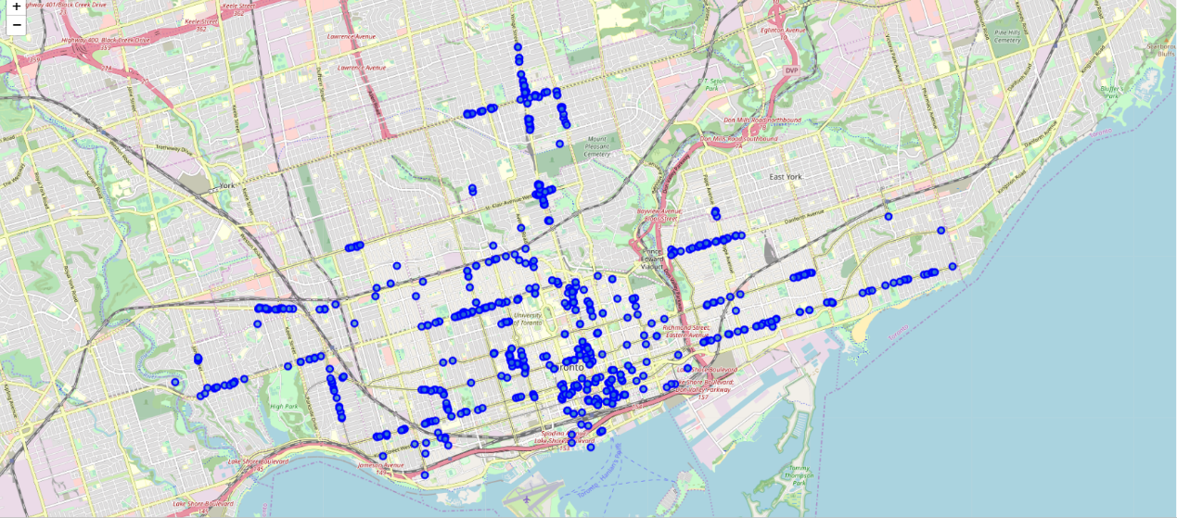

Map 1: All Nearby Restaurants within the 1km Radius of Each Neighborhood of Toronto

According to Map 1, we can see a clear pattern that restaurants are located densely in the central area of Toronto but much less densely in surrounding areas. Using the Toronto map from the *Maps of the World* (Map 2), we can see that areas such as East York, Cork Town and the Junction have a great number of restaurants. Hence, opening a new restaurant in such areas can be both beneficial and risky. On the one hand, these areas comprise the downtown of the Toronto city offering great customer bases. On the other hand, the competition and costs such as leasing fees will also be higher. However, the density of restaurants in surrounding areas is much lower relative to the density of central areas. For example, areas such as High Park North, Westmount and Scarborough have fewer blue points.

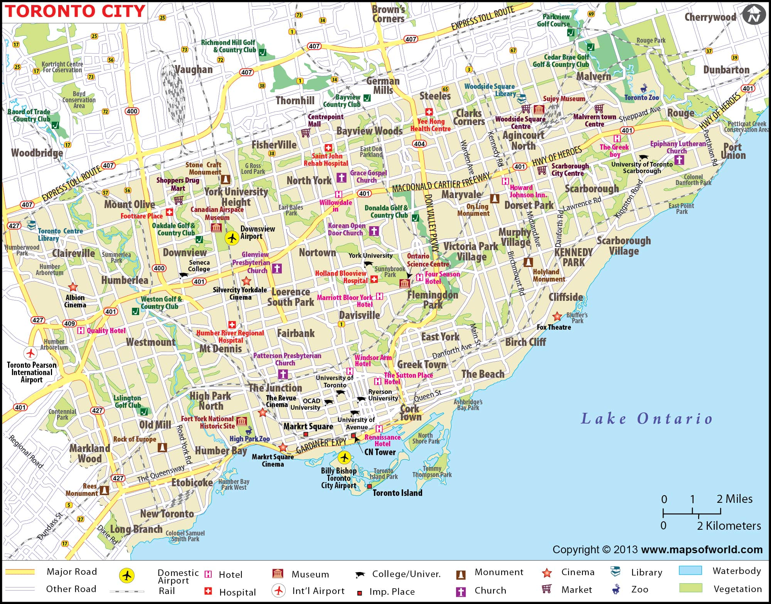

Map 2: The Map of Toronto from Maps of the World <https://www.mapsofworld.com/canada/toronto-map.html>

I also plot all Chinese restaurants on the Toronto map (Map 3) and we can see there are just a few blue points scattered on the map. It can be inferred that the competition from peer restaurants would be small and thus, it should be a good choice to start up a new Chinese restaurant in Toronto if we can find the right location.

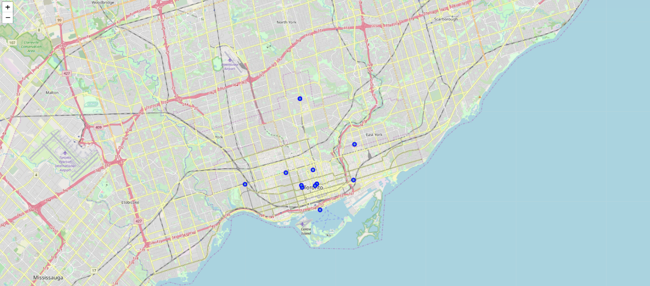

Map 3: Chinese Restaurants of Toronto

Next, I am trying to figure out the most common restaurants in each neighborhood by calculating the frequency of occurrence of each restaurant category and pick out top 10 restaurant categories. I plot the 1st, 2nd and 3rd most common restaurant categories among all neighborhoods.

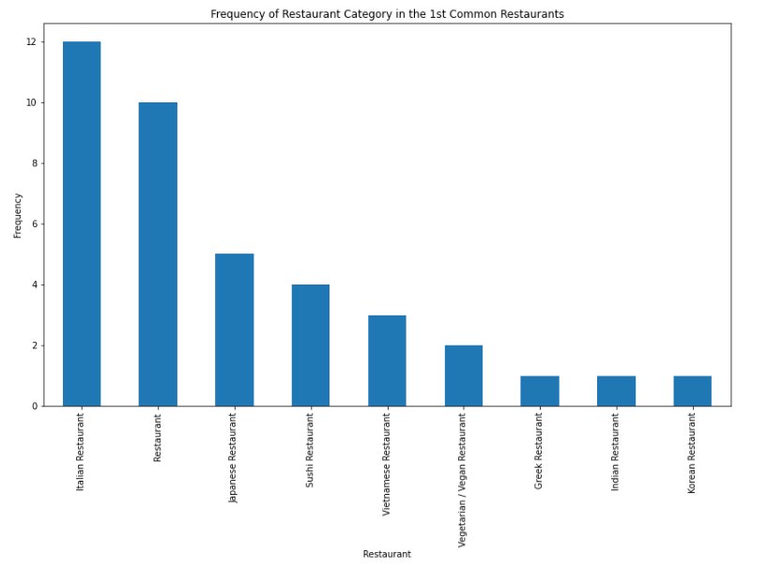

Graph 1: Frequency of Restaurant Category in the 1st Most Common Restaurants

It can be noticed that Italian Restaurants following by general restaurant and Japanese restaurants are the most common restaurant categories for all neighborhoods indicating great potential competition pressure from these types of restaurants. Another interesting finding is that we don’t see ‘Chinese Restaurants’ in the graph above showing less competition from local Chinese restaurants.

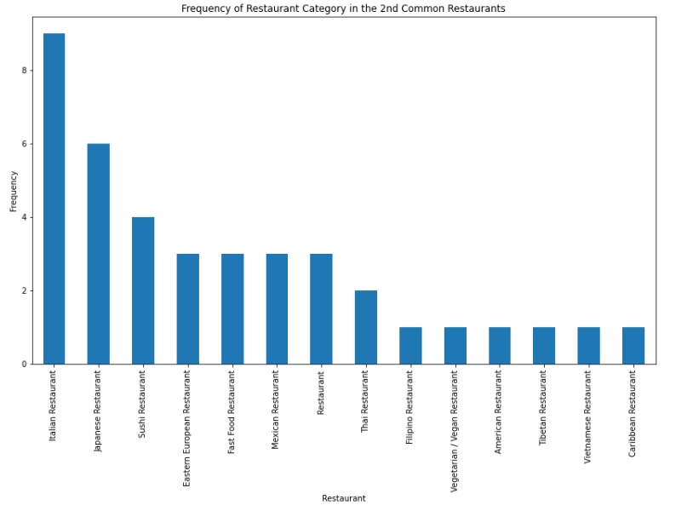

Graph 2: Frequency of Restaurant Category in the 2nd Most Common Restaurants

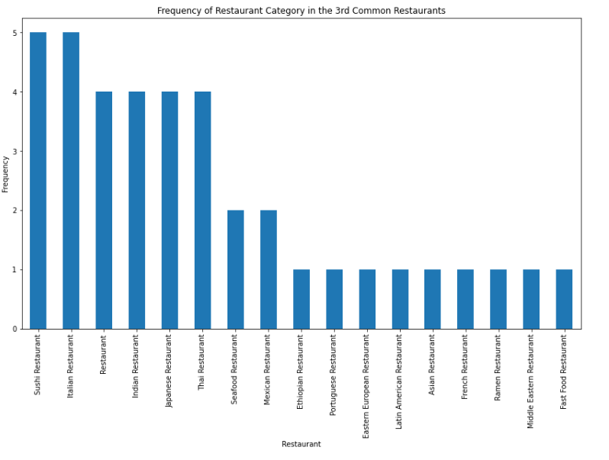

Graph 3: Frequency of Restaurant Category in the 3rd Most Common Restaurants

Graph 2 and 3 show similar patterns of Graph 1 that Italian, general type and Japanese restaurants are most commonly observed restaurants in Toronto. Other categories such as Indian, Thai or Vietnamese are also popular restaurant categories in Toronto. Chinese restaurants do not show up in any of the above graphs.

To further examine the relationship between neighborhood and restaurant categories, I use the method of k-means (where K = 5) clustering to cluster all neighborhoods based on the ‘most common restaurant categories within each neighborhood’ and plot them on the Toronto map (Map 4).

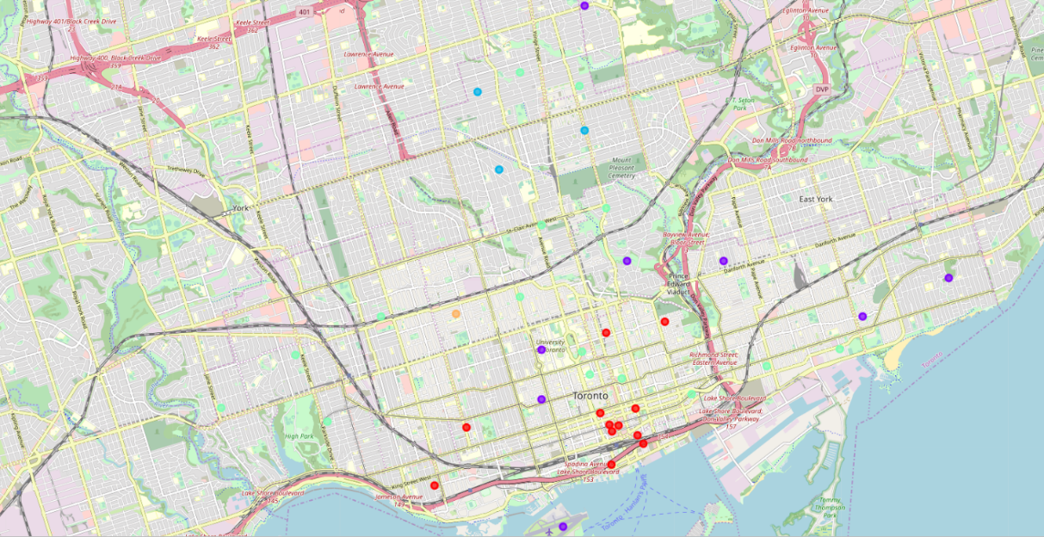

Map 4: Clustered Neighborhoods based on Restaurant Categories

We can clearly identify 5 clusters from Map 4 according to colors. Specifically, cluster 1 (‘red’) refer to the general restaurant category; cluster 2 (‘purple’) stands for restaurant categories of Vietnamese, Vegetarian/Vegan and Japanese; cluster 3 (‘blue’) and 4 (‘green) refer to Sushi restaurant and Italian restaurant, respectively; and cluster 5 (‘orange’) is the cluster of other types of restaurants. It can be observed that red and green labels are mostly located in the downtown area of Toronto while purple labels scattered in surrounding areas. Blue points are basically located in the northern part of Toronto.

**Population Density Analysis**

After examining the distribution of restaurants within each neighborhood in the city of Toronto, the next step is to investigate the population distribution of each neighborhood by first looking at the table of ‘Top 20 ethnic origins in the City of Toronto’ scraped from the Wiki page of ‘Demographics of Toronto’ (Table 1). We can see that the Chinese group with a population of 332,830 accounts for approximately 12.5% of the overall population of Toronto city. The size of the Chinese ethic origin even exceeds the English origin, which only make up 12.3% of the total population of Toronto. In addition, the table also indicates that ridings with the highest Chinese concentration are Scarborough-Agincourt where over 47% of the local population is made up of Chinese.

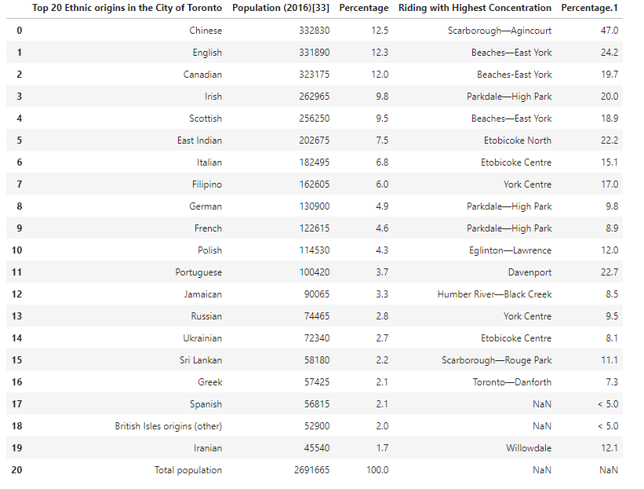

Table 1: Top 20 Ethnic Origins in the City of Toronto

In addition, if we take a further look at the ethnic group by main individual boroughs such as Toronto & East York, North York, Scarborough and Etobicoke & York (Table 2 – 5), we can find that Scarborough has the highest concentration of the Chinese ethnic group (the density of Chinese ethnic group reaches 45.8% of the overall population of Agincourt in Scarborough). Hence, it may be a good choice to open a Chinese restaurant in such areas since they can provide a really good customer base for a new restaurant.

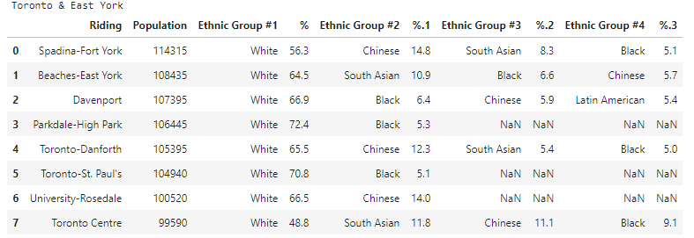

Table 2: Ethnic Groups in Toronto & East York

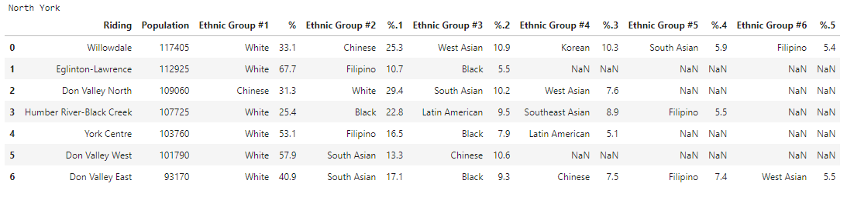

Table 3: Ethnic Groups in North York

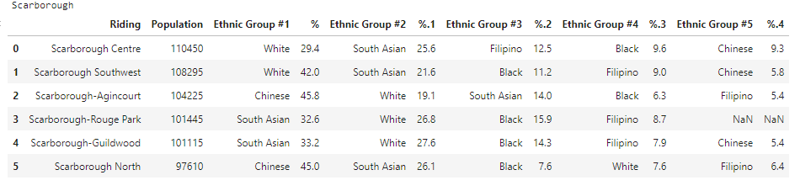

Table 4: Ethnic Groups in Scarborough

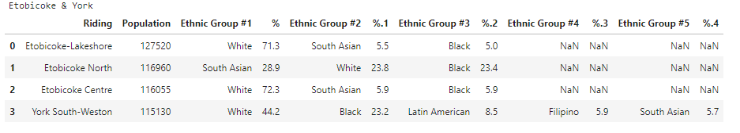

Table 5: Ethnic Groups in Etobicoke & York

**Conclusion**

**Based on my analysis, opening a new Chinese restaurant in Toronto is a good opportunity. First, Toronto is a multicultural city which has a wide range of restaurant categories. Hence, a new Chinese restaurant will be easily accepted by local people. Second, Chinese restaurants are not very common in this city indicating less competition pressure from peer members. Third, districts such as Scarborough have a great number of Chinese residents providing good customer basis for a new restaurant. Therefore, it can be a good choice to start up a new Chinese restaurant in Toronto. However, selecting areas such as downtown Toronto may also be risky as the competition from other restaurant categories such as Italian and Japanese restaurants can also be very serious.**